# Populating Generate ETL Checklists

Global conventions

* Schema names for a table should not be included since they are the same for every table listed.
* If multiple fields are referenced in the same cell, then they should be comma delimited. (e.g. “RefPersonStatusTypeId (Migrant), StatusValue”
* If a field value is referenced, then the code (e.g. “(Migrant)”) should be reference instead of the id value. We want the flexibility to change the id value without updating the spreadsheet.
* “Not Selected” values for a field should be included unless explicitly not used in the Generate ETL.
* If multiple student identifiers are required for processing, then they will be listed as separate rows. (e.g. if reporting contains students in an early learning environment and K-12 students then both identifiers would be listed)
* Fields that do not carry forward to the RDS will be labeled "N/A - Not Migrated to the RDS. This information is used for troubleshooting or for determining the applicable year for reporting". Typically, these will be identifier information (such as ID numbers or person name) or participation/enrollment dates.
* If a date or numeric field is used in an RDS Fact Table (e.g. FactPersonnelCounts.PersonnelFTE or FactStudentDisciplines.DisciplineDuration) then the Destination RDS Dimension Table Name and Destination RDS Dimension Column Name will be labeled “N/A - There is no dimension for this field.”

CEDS Data Type

Following the convention from the CEDS Domain Entity Schema (DES) this value will only be populated for date and alphanumeric fields. Fields with an option set (represented in the CEDS ODS as bit and int fields) will be blank.

**Example values:**

* + alphanumeric - (35)
  + alphanumeric - (40)
  + YYYY-MM-DD
  + Numeric - between 0 and 1, up to 2 digits (example: Staff Full Time Equivalency)

Destination ODS Column Name

RefPersonStatusTypeId - Certain demographic fields (for example: Migrant Status, Economic Disadvantage Status, English Learner Status, IDEA Indicator, Homelessness Status) in the ODS use RefPersonStatusTypeId. We will include the code in the Destination ODS Column Name. The value in this cell will look like this:

|  |  |
| --- | --- |
| **CEDS Element Name** | **Destination ODS Column Name** |
| Migrant Status | RefPersonStatusTypeId (Migrant), StatusValue |
| Economic Disadvantage Status | RefPersonStatusTypeId (EconomicDisadvantage), StatusValue |
| English Learner Status | RefPersonStatusTypeId (LEP), StatusValue |
| IDEA Indicator | RefPersonStatusTypeId (IDEA), StatusValue |
| Homelessness Status | RefPersonStatusTypeId (Homelessness), StatusValue |
| Homelessness Status | RefPersonStatusTypeId (Homelessness), StatusValue |

CEDS Option Set Code

This value should make the option code set show in CEDS even if it differs in the ODS.

## EDFacts File Spec Number(s)

There can be multiple ED*Facts* File Spec Numbers associated with each column.

In this case format them as comma delimited within the cell.

Example: FS029, FS039, FS129

## Destination RDS Report Column Name

Variables that are capitalized in the table (e.g. “AGE”) should be capitalized in the Checklist.

## How to get the CEDS Element Data Model ID

The CEDS Element Data Model ID is one of three columns in the ETL Checklists needed for using the CEDS Align mapping tool. The columns (CEDS Element Data Model ID, Definitions Response ID, Option Set Response ID) need to be populated correctly to be uploaded into CEDS.

1. Go to the Domain Entity Schema site

<https://ceds.ed.gov/domainEntitySchema.aspx>

1. Navigate to the element name and click on it

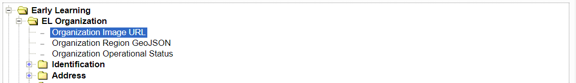

1. Copy the CEDS URL at the bottom of the window

https://ceds.ed.gov/CEDSElementDetails.aspx?TermxTopicId=41974   (Email this link)

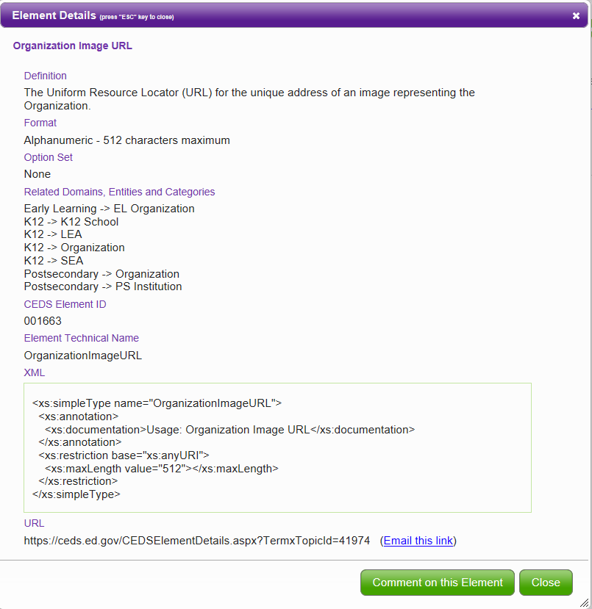

1. Copy just the ID number at the end of the link.

In this example: 41974

The following CEDS Elements search function can be used to find variables. This works better than the Domain Entity Schema site search functionality. It returns more complete results.



<https://ceds.ed.gov/elements.aspx>

